1. **Installing Packages:-**

It’s important to note that the term “package” in this context is being used as a synonym for a distribution (i.e. a bundle of software to be installed), not to refer to the kind of package that we import in your Python source code (i.e. a container of modules). It is common in the Python community to refer to a distribution using the term “package”. Using the term “distribution” is often not preferred, because it can easily be confused with a Linux distribution, or another larger software distribution like Python itself.

1. **Ensure you can run Python from the command line:-**

We have Python and that the expected version is available from your command line. You can check this by running:

**python --version**

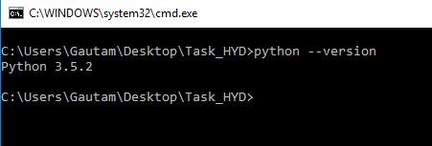

You should get some output like Python 3.5.2. If you do not have Python, please install the latest 3.x version from [python.org](https://python.org/)

1. **Ensure We can Run pip for the Command Line:-**

Additionally, you’ll need to make sure you have [pip](https://packaging.python.org/key_projects/#pip) available. You can check this by running:

**pip --version**

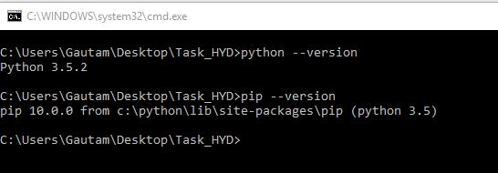

1. **Use pip for Installing:-**

[**pip**](https://packaging.python.org/key_projects/#pip) is the recommended installer.

1. **Installing from PyPi:-**

The most common usage of [pip](https://packaging.python.org/key_projects/#pip) is to install from the [Python Package Index](https://packaging.python.org/glossary/#term-python-package-index-pypi) using a [requirement specifies](https://packaging.python.org/glossary/#term-requirement-specifier). Generally speaking, a requirement specifies is composed of a project name.

To install the latest version of “Some Project”:

**pip install 'SomeProject'**

To install a specific version:

**pip install 'SomeProject==1.4'**

To install greater than or equal to one version and less than another:

**pip install 'SomeProject>=1,<2'**

To install a version that’s [**“compatible”**](https://www.python.org/dev/peps/pep-0440#compatible-release) with a certain version:

**pip install 'SomeProject~=1.4.2'**

In this case, this means to install any version “==1.4.*” version that’s also “>=1.4.2”.

1. **Upgrading Packages:-**

Upgrade an already installed Some Project to the latest from PyPI.

**pip install --upgrade SomeProject**

1. **Installing To the User Site:-**

To install [packages](https://packaging.python.org/glossary/#term-distribution-package) that are isolated to the current user, use the **-- user** flag:

**pip install --user SomeProject**

1. **Requirements File:-**

Install a list of requirements specified in a [Requirements File](https://pip.pypa.io/en/latest/user_guide/#requirements-files).

**pip install -r requirements.txt**

1. **Freeze all dependencies from the Project:-**

Go to the root project and run this code on command prompt.

**pip freeze > requirements.txt**